The Hawthorn
CONNECTION

EST. 1978 Q4 Nov 2014 10820 Sunset office Dr., 3rd Floor, St. Louis MO 63127 800-899-5757

Cybersecurity and Healthcare

Hackers Seeking Healthcare Data

In August 2014 the Arizona Star newspaper reported that cyber criminals had been stealing personal data from patients in the Tucson area. Over a five-year period the thieves had stolen patients’ names, addresses and Social Security numbers from local healthcare organizations. Stolen patient information of this type is often sold on black markets, where health data commands a higher price than information stolen from retail companies or financial institutions. Health records tend to include details that can be used to access bank accounts or to obtain prescriptions for controlled substances.

The Department of Health & Human Services (www.hhs.gov) reports on its website all breaches of health information affecting more than 500 individuals. This site lists nearly 100 pages of organizations—representing over 30 million individuals—whose information has been hacked. It is fair to say that cybersecurity is an issue that will continue to affect healthcare organizations of all sizes and types.

Early in 2014 the National Institute of Standards and Technology (NIST) issued a 41-page document that describes the Cybersecurity Framework for protecting 16 of our nation’s critical infrastructures, including healthcare. The NIST framework is a collaborative and voluntary effort between public and private organizations, and its purpose is to provide a set of industry standards and best practices for managing cybersecurity risks. Visit the Hawthorn website (www.hawthorngrp.com/resources.html) to read “Cybersecurity and Healthcare”, our article describing the NIST initiative in more detail.

Employee Spot Lights

Going for the Gold Award:
Brad M., Judi J., Anita R., & Kathy H.
3rd Qtr. Winner:
Brad M.

Top 10 Biggest HIPAA Breaches By: Healthcare IT News September 2014
The numbers are scary. Healthcare providers and payers, together with their business associates, are still failing to protect patient privacy and ensure the security of their personal health information. The drumbeat of data violations continues: To date, more than 38.7 million individuals have had their protected health information compromised in HIPAA privacy and security breaches. Here are the biggest offenders.
Slideshow: Top 10 biggest HIPAA breaches (control & click on link for full article)

_________________________________________

ICD10 Talk Ten Tuesdays- ICD-10: Ready or Not? Listen to this week’s podcast.

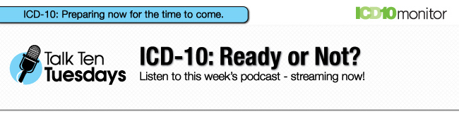
Control & Click on the download button below to listen to a recording broadcast.

If you would like to listen to more Talk Ten Tuesdays podcasts, please click here or find us on iTunes. Talk Ten Tuesdays. More than just talk.™

Hawthorn Cares!
Hawthorn Physician Services has made a commitment to a volunteer program with Stray Rescue of St. Louis. We have invited our staff to take part in a paid volunteer day once a year to give their time to help out with the Stray Rescue mission.
“We had lots of fun even though it was actually a lot of work!! For 2 hours straight we walked dogs that were super excited and not leash trained at all. This made these walks a complete work out. All the dogs were adult pit bull mixes and some have been at the shelter for years. It was sad knowing that just because of their breed that some of them will never have a home other than the shelter. The shelter staff and numerous volunteers we met that day were very generous people that truly love and care for these dogs.” Laura B., AR Department


Addressing Complexity with Certainty

